Detailed Implementation Document
Weblogic OSB PREPROD

Author: Relocation Architect Henrik Ridder / Sami Marjokorpi
Owner: Account Architect Mats Samuelsson
Document Date: 04-08-2016
Customer: Finnair

Finnair DID Weblogic OSB_PREPROD v0.12
Document History
Document Location
This document is only valid on the day it was printed. Ensure that this document is current. Printed documents and locally copied files will become obsolete due to changes to the master document.
Latest version can be found in the FINNAIR T&T community:
https://apps.na.collabserv.com/activities/service/html/mainpage#activitypage,56cfd7bf-e2d5-4f77-ad61-bfe5ca7d18ba
Revision History
Revision Number | Revision Date | Summary of Changes / Iteration Level | Changes marked
0.1 | 04 April 2016 | Henrik Ridder Initial version | N
0.2 | 08 April 2016 | Henrik Ridder Added all network configuration | N
0.3 | 13 April 2016 | Peer review by Sami Marjokorpi | N
0.4 | 18 April 2016 | Review by Allan Unnerup | N
0.5 | 20 April 2016 | Review by Seppo Pöyhönen / Finnair | N
0.6 | 25 April 2016 | Added worldtracer connection in drawings | N
0.7 | 26 April 2016 | Removed references to Oracle databases | N
0.8 | 13 May 2016 | Removed remaining references to Oracle databases in table 5-16 | N
0.9 | 29 May 2016 | Added db connections to partner services in 3.2 and 5.4 | N
0.10 | 02 June 2016 | Changed target network zone to DMZ | N
0.11 | 4 Aug 2016 | Added webserver | N
0.12 | 5 Sep 2016 | Updated based on Mikko Iivonen’s comments | N
Approvals
This document requires approval from the following. Signed approval forms are filed in the FINNAIR T&T community
Name | Title / Organization
Matti Alanne | Architect /Service Manager Finnair
Mikko Iivonen | T&T Architect / IBM
Seppo Pöyhönen | Architect / Finnair
Ari Maronen, | Service Manager / Finnair
Distribution
This document has been distributed to the following people / organizations.
Name | Title / Role / Organization
Matti Alanne | Architect / Finnair
Jason Papadopoulos | Project Manager / Finnair
Sanjay Munshi | Enterprise Platforms Tower Lead / Project Manager / IBM
Mats Samuelsson | Chief Architect / Finnair Account Architect / IBM
Mikko Iivonen | Architect / T&T Architect / IBM
Taito Halonen | Platform Responsible / IBM
Bent Gregersen | Database Responsible / IBM
Jyrki Seppä | IT Delivery, SSO / IBM
Staffan Wall | Project Manager / IBM
Contents

Contents
Document History 2
Document Location 2
Revision History 2
Approvals 2
Distribution 3
Contents 4
Contents 4
1. Executive Summary 7
2. Preface 8
2.1 Introduction & Background 8
2.2 Purpose of this Document 8
2.3 Input Sources for this Document 8
2.4 Scope 8
2.4.1 Included in Scope 8
2.4.2 Excluded from Scope 8
2.5 Stakeholder Details 8
2.6 Statement of Assumptions 9
2.7 Definitions & Glossary 9
2.8 Copyright 10
3. Current System 11
3.1 Current System Context 11
3.2 Current Application Model and Interfaces 12
3.3.1 Application Details 13
3.3.2 Application Interfaces 13
3.3.3 Users 19
3.3.4 Printing 20
3.4 Current Operational Model 20
3.4.1 Current IT Environment 20
3.4.2 Current Platform/Node Descriptions 21
3.4.3 Current Server Details 22
3.4.4 Current Storage and Database Information 23
3.5 Current Network Model 24
3.5.1 Network Topology 24
3.5.2 Current Network Connections 24
3.6 Current Environments Model 24
3.7 Current Systems Management Model 25
3.7.1 Availability 25
3.7.2 Backup & Recovery Management 25
3.7.3 Operations Management 25
3.7.4 Batch Management 25
3.7.5 Performance / Capacity Management 25
3.7.6 Change Management 25
3.7.7 Configuration / Inventory Management 25
3.7.8 Security Management 25
3.7.9 Disaster Recovery / Continuity Management 25
3.7.10 Problem Management 26
3.7.11 Data Management 26
3.7.12 Software Control & Distribution 26
3.7.13 Service Level Management 26
4. Requirement Analysis 27
4.1 Applicable Documentation 27
4.2 Acceptance 27
4.3 Finnair Responsibilities 27
4.4 Change Cases 27
5. Target Solution 28
5.1 Target Solution Overview 28
5.2 Target System Context 28
5.3 Target Operational Model 28
5.3.1 Architectural Decisions 29
5.3.2 Target Server details 29
5.3.3 Target Storage & Database Information 31
5.4 Target Network Model 32
5.4.1 Target Network Topology 32
5.4.2 Target Network Connections 32
5.5 Target Systems Management Model 39
5.5.1 Availability 39
5.5.2 Backup & Recovery Management 39
5.5.3 Operations Management 39
5.5.4 Batch Management 39
5.5.5 Performance / Capacity Management 39
5.5.6 Change Management 39
5.5.7 Configuration / Inventory Management 39
5.5.8 Security Management 39
5.5.9 Disaster Recovery / Continuity Management 39
5.5.10 Problem Management 40
5.5.11 Data Management 40
5.5.12 Software Control & Distribution 40
5.5.13 Service Level Management 40
5.6 Testing and Validation 41
5.7 System Acceptance 41
5.8 Deployment 41
5.9 Documentation 41
6. Transformation guidelines 43
7. Service Move 44
7.1 Cutover Plan 44
7.2 Move Day Timeline 44
7.3 Communication plan 44
7.4 Rollback plan 44
7.5 Risk Assessment 44

Executive Summary
The Weblogic OSB environment is based on Weblogic Server 10.3.0.6 and Oracle Service Bus 11.1.1.7 with multiple applications.
The applications are used by tens of users.
The Weblogic OSB system is a critical system running at Gold level SLA.
The Weblogic OSB system is available in a pre-production setup (this DID), also a production setup exists, but is not part of this DID. The Weblogic OSB applications are accessed by other applications and programs, eg. Finnair.com website.
OSB application are using Load Balancing setup in both production and Preproduction environment.
This DID does not cover this part, solution for Load Balancing will be determined separate in workshops with Neos, IBM and FINNAIR.
The Weblogic OSB system will be reinstalled and transformed to a central application running in IBM DC.
Data migration will be done via production LAN.
Migration and cutover plan will follow general template and approach, and this can be seen in other documents.
Note, this DID only covers the Pre-production server DHWAPA1

Baseline
Current System Information
Server name | Node type | Type/Model | Serial number | No. of CPUs | Memory | Location
DHWAPA1 | Physical | AIX 5.3 64 bit | N/A | 2 | 16 GB | NEOS DC

Target System Information
Server Name | Node type | Type/Model | Serial Number | No. of CPUs | Memory | Location
AYVATOSBAP01 | Virtual | AIX 7.1 64 bit | N/A | 2 | 16 GB | IBM DC

Preface

Introduction & Background
The agreed servers at Neos are to be transformed and relocated from the current location in the Neos datacentre to IBM’s dual site computing centre in Suvilahti and Munkkiniemi..

Purpose of this Document
- Provide a vision of the architecture and scope of the proposed IT system
- Enable recognition and validation of the implications of the architectural approach
- Ensure a complete migration of the system and all of it components

Input Sources for this Document
The following sources were used as references in the preparation of this document, but they are specifically not part of the Solution Design Definition.

- MASTER Finnair Servers Baseline 160314.xlsx
- Application_list-2015-08-25T10-42-40.xlsx
- questionnaire for ITOSB PRE_PROD_SP_v2.xlsx
- AYCRM_Firewall_Rules_V_14.xlsx
- Finnair Mobile Architecture_v1.1.docx

Scope

Included in Scope
The following are specifically included in scope:
- The servers listed in the tables in section 3.3.3 Current Server Details as these are the definitive list of servers/devices that will be transformed and relocated. These tables take precedence over any other list in this document.

Excluded from Scope
The following are specifically excluded from the relocation scope:
None identified.

Stakeholder Details
The contact details for all individual stakeholders are listed in the table below.

Table 2-1 Stakeholder Details
Role | Responsibilities | Name | E-mail | Mobile phone number
Service Manager (Finnair) | Owner of the application/service | Ari Maronen | ari.maronen@finnair.com | +358503931915
Business owner | Support to application | Ari Maronen | ari.maronen@finnair.com | +358503931915
Architect | Finnair’s responsible architect | Seppo Pöyhönen | seppo.poyhonen@finnair.com | +358405933321
Project Manager | Finnair’s responsible project manager | Jason Papadopoulos | jason.papadopoulos@finnair.com | ´+358505232533
Application Administrator | Administrator of the application | CGI / IBM | CGI: lassi.jatkola@cgi.com | +358503905834
Software vendor (If applicable) | Support / Maintenance | CGI / IBM / Oracle
OSB specialist | Installation and configuration | Bent E Gregersen | bege@dk.ibm.com | +45 4120 3864

Statement of Assumptions
N/A

Definitions & Glossary
Term | Description
SUV | Suvilahti  One of the sites at CDC Finland
MUN | Munkkiniemi.  One of the sites at CDC Finland
CDC | Central Data Centre
DID | Detailed Implementation Document
ISM | IBM Service Management
ODBC | Open Data Base Connectivity
PIT | CGI Location
RDP | Remote Desktop Protocol
RPE2 | Relative Performance Estimate version 2
SAN | Storage Area Network
SCCM | System Centre Configuration Manager
SLA | Service Level Agreement
SMB | Server Message Block  A request-response protocol for sharing files, printers, serial ports, and communications abstractions such as named pipes and mail slots between computers.
SP2 | Service Pack 2
SQL | Structured Query Language
UAT | User Acceptance Test
USB | Universal Serial Bus
VPN | Virtual Personal Network
WAN | Wide Area Networks

Copyright
IBM has copyright and intellectual property rights on the contents of this document.
© Copyright 2016. IBM Corporation. All Rights Reserved.

Current System
This chapter describes the architecture of the current environment.

Current System Context
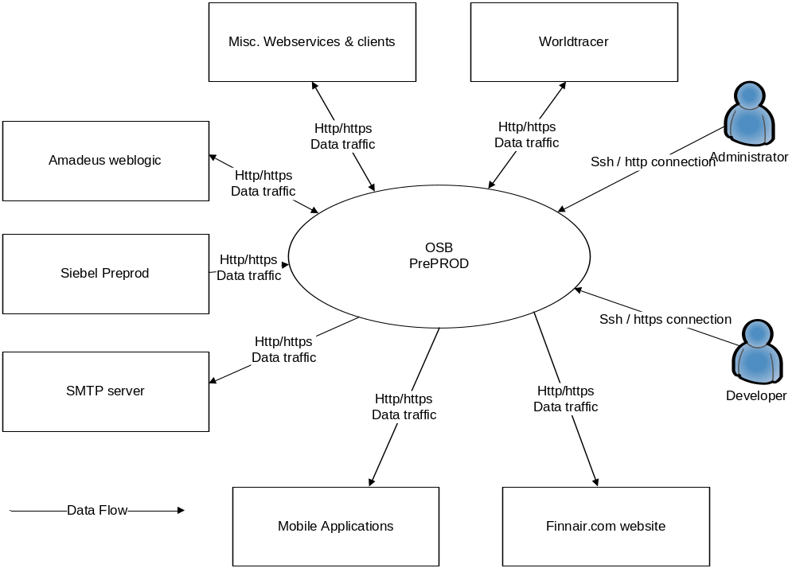

Figure 3-1 System Context Diagram
OSB provides Web Services (SOAP and REST/JSON) for Finnair.com website, Mobile application and partner integrations.
There are around 100 services in internal and external use.
OSB Version: 11.1.1.7
Java version: Aix java6_64
Around 100 OSB business services runs on server, mostly synchronous online services but also some file based integrations.
No configuration database exists, but monitoring report oracle DB. OSB configurations are properly saved on server.
Certificates used is self-signed, but SSL offloading, where used, is done in the HTTP server layer so this should not be of significant importance. Some outgoing https exist, like Google Analytics.

Current Application Model and Interfaces
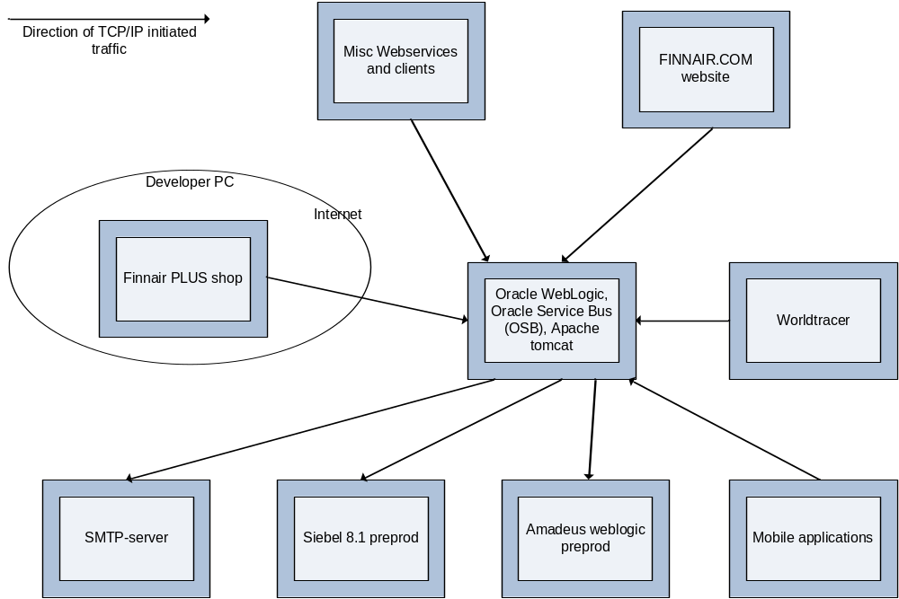
Figure 3-2 Component Model
Oracle Service Bus (OSB) is installed on top of Oracle WebLogic server and it is used as a integration gateway between different applications. Most important systems that are integrated via OSB are Siebel, Amadeus, Worldtracer, Finnair.com nad Finnair mobile applications.
SMTP-server is used to send monitoring information to administrators and developers.
Apache tomcat webserver is used to host mock services of external systems for testing purposes.

Application Details
IO-code: ITOSB Preprod
Criticality: 1
Table 3-2 Current Application List
Application / product name | Version | Vendor | Dist. Package | Comment
Weblogic | 10.3.0.6 | Oracle |  | Manual installation done by IBM, assisted by CGI.
Oracle Service Bus (OSB) | 11.1.1.7 | Oracle |  | Manual installation done by IBM, assisted by CGI.
Apache tomcat | 6.0.37 | Apache |  | Manula installation done by IBM

Application Interfaces
Both DNS lookup and hardcoded IP addresses are used in application
Table 3-3 Application Interfaces
From | To | Data | Type | Comments
OSB Application server | 157.200.88.165 | Siebel 7.8 PREPROD Web Server Load balancer address | 80, 443 | NA
OSB Application server | 157.200.88.176 | Siebel 7.8 TEST2 Web Server address | 80 | NA
OSB Application server | 157.200.88.170 | Siebel 7.8 TEST1 Web Server address | 80 | NA
OSB Application server | 157.200.15.211 | prewww.finnair.fi - preproduction internet front-end | 80, 443 | NA
OSB Application server | 157.200.18.62 | ADN / Missing points through WBI | 7080 | NA
OSB Application server | 157.200.13.44 | SMTP Gateway | 25 | NA
OSB Application server | 157.200.88.165 | Siebel 7.8 PREPROD Web Server Load balancer address | 80, 443 | NA
OSB Application server | 157.200.88.176 | Siebel 7.8 TEST2 Web Server address | 80 | NA
OSB Application server | 157.200.88.170 | Siebel 7.8 TEST1 Web Server address | 80 | NA
OSB Application server | 57.250.224.196 | WTR | 443 | NA
OSB Application server | 172.19.98.10 | Siebel 8.1 PREPROD Web Server Load balancer address | 80, 443 | NA
OSB Application server | 157.200.88.180 | Siebel 7.8 Preprod DB server | 50000 | NA
OSB Application server | 74.125.39.101, 74.125.39.102, 74.125.39.113, 74.125.39.138, 74.125.39.139, 74.125.39.100 | Google Analytics | 80 | NA
OSB Application server | 82.150.226.67 | test.webservices.amadeus.com | 443 | NA
OSB Application server | 82.150.226.67 | test.webservices.amadeus.com | 443 | NA
OSB Application server | 209.85.146.100, 209.85.146.101, 209.85.146.102, 209.85.146.113, 209.85.146.138, 209.85.146.139 | www.google-analytics.com | 80 | NA
OSB Application server | 172.19.100.164 | Proxy Server | 3128 | NA
OSB Application server | 157.200.19.252 | BPM Oracle UAT Database | 1525 | NA
OSB Application server | test-ads.webservices.ay.amadeus.net:22006  193.23.185.93:22006 | Altea Data Nexus TEST Environment | 22006,80 | NA
OSB Application server | prod-ads.webservices.ay.amadeus.net:22006  194.76.166.93 | Altea Data Nexus PROD Environment | 22006,80 | NA
OSB Application server | test.webservices.1a.amadeus.net  193.23.185.67 | Amadeus PDT Environment | 22006, 80 | NA
OSB Application server | gw1.roottori.fi  87.108.54.100 | SMS Gateway Provider - Roottori | 80, 443 | NA
OSB Application server | es30.bookit.net  193.185.151.60 | SMS Gateway Provider - BookIT | 8080, 443 | NA
OSB Application server | 172.19.98.10 | Siebel Loyalty PRE-PROD Environment | 80 | NA
OSB Application server | 172.19.96.234 | Siebel Loyalty PROD Environment | 80 | NA
OSB Application server | 157.200.18.17 | BPM UAT Environment | 8080, 8070,  9090, 9080 | NA
OSB Application server | preprod.finnair.fi  157.200.18.11 | Scope PRE-PROD Environment | 80 | NA
OSB Application server | 157.200.16.188 | Data warehouse DB2 Database | 50000 | NA
OSB Application server | 157.200.88.185 |  | 80, 443 | NA
OSB Application server | 157.200.74.164 | Scope PRE-PROD Server | 80 | NA
OSB Application server | 157.200.75.35 | Scope Prod | 80, 443 | NA
OSB Application server | 62.61.85.34 | Rottori | 80, 443 | NA
OSB Application server | 172.19.98.10 | Preprod Web server | 9704 | NA
OSB Application server | 172.19.98.74 | Preprod Siebel Server 1 | 1414 | NA
OSB Application server | 172.19.98.236 | Preproduction middlware load balancer | 80 ,443 | NA
OSB Application server | nodeA1.test.webservices.1a.amadeus.com/ 171.17.15.33 | Amadeus Test Webservice | 80/443 | NA
OSB Application server | es30.bookit.net/193.185.151.60 | BookIT Test | 8080/443 | NA
OSB Application server | 157.200.93.25 | SMTP Server | 25 | NA
OSB Application server | www.oneworld.com (66.96.130.69) | Amadeus Test Webservice | 80/443 | NA
OSB Application server | www.web-mn.com (23.23.175.3, 107.20.199.207) | Amadeus Test Webservice | 80/443 | NA
OSB Application server | go.urbanairship.com (184.31.89.14) | Amadeus Test Webservice | 80/443 | NA
OSB Application server | 217.140.134.8 | sms gateway | 80 | NA
OSB Application server | sns.eu-west-1.amazonaws.com (176.32.110.38 )dynamic ip address | Amadeus Test Webservice | 443 | NA
OSB Application server | 10.100.160.90, 10.100.160.91, 10.100.160.100, 10.100.160.101, 10.100.160.102 | AYDWH Mob Ops DB | 1521 | NA
OSB Application server | webservice-qa.worldtracer.aero: (57.250.200.177) | Amadeus Test Webservice | 443 | NA
OSB Application server | 157.200.32.40 |  | 7300 | NA
OSB Application server | 157.200.32.40 |  | 7301 | NA
OSB Application server | 171.17.128.42 | wav.finnair.com | 80/443 | NA
OSB Application server | 171.17.128.123 |  | 80/443 | NA
OSB Application server | 157.200.40.0/22 |  | 80/443 | NA
OSB Application server | 157.200.40.0/22 |  | 6379 | NA
OSB Application server | 157.200.74.158 |  | 389 | NA
OSB Application server | Auth.exacttargetapis.com |  | 80,443 | NA
OSB Application server | Auth-test.exacttargetapis.com |  | 80,443 | NA
OSB Application server | www.exacttargetapis.com |  | 80,443 | NA
OSB Application server | 85.222.128.0/19 | SFDCRIPE1 | 80/443 | NA
OSB Application server | 85.222.128.0/19 | SFDCRIPE1 | 1024–66535 | NA
OSB Application server | 185.79.140.0/22 | SFDCRIPE2 | 80/443 | NA
OSB Application server | 185.79.140.0/22 | SFDCRIPE2 | 1024–66535 | NA
OSB Application server | 202.129.242.0/23 | SFDCAPNIC1 | 80/443 | NA
OSB Application server | 202.129.242.0/23 | SFDCAPNIC1 | 1024–66535 | NA
OSB Application server | 182.50.76.0/22 | SFDCAPNIC2 | 80/443 | NA
OSB Application server | 182.50.76.0/22 | SFDCAPNIC2 | 1024–66535 | NA
OSB Application server | 85.222.128.0/19 | SFDCRIPE1 | 80/443 | NA
OSB Application server | 185.79.140.0/22 | SFDCRIPE2 | 80/443 | NA
OSB Application server | 96.43.144.0/20 | SFDCARIN1 | 80/443 | NA
OSB Application server | 136.146.0.0/15 | SFDCARIN2 | 80/443 | NA
OSB Application server | 204.14.232.0/21 | SPDCARIN3 | 80/443 | NA
OSB Application server | 10.100.132.198 | ORACLE | 1521 | NA
OSB Application server | 10.100.132.197 | ORACLE | 1521 | NA
OSB Application server | 1.010.016.042 | ORACLE | 1521 | NA
OSB Application server | 172.19.100.171 | SMTP | 25 | NA
Finnair Network | OSB Application server | PREPROD MIDDLEWARE SERVER | 22 - SSH  7005, 7070, 7080 - HTTP  7043, 7053, - HTTPS  8005, 8070, 8080 - HTTP  8043, 8053- HTTPS | NA
Logica Access | OSB Application server | PREPROD MIDDLEWARE SERVER | 22 - SSH  7005, 7070, 7080 - HTTP  7043, 7053, - HTTPS  8005, 8070, 8080 - HTTP  8043, 8053- HTTPS | NA
ITC Infotech Network / VPN | OSB Application server | PREPROD MIDDLEWARE SERVER | 22 - SSH  7005, 7070, 7080 - HTTP  7043, 7053, - HTTPS  8005, 8070, 8080 - HTTP  8043, 8053- HTTPS | NA
Siebel App 1 | OSB Application server | Proxy Server | 7070 | NA
Siebel 8.1 PROD App Server | OSB Application server | Preprod Middleware Server | 80 | NA
Pre-prod application servers | OSB Application server | Production Application Server | 5080, 6080 | NA
PRE-PROD INFORMATICA SERVER | OSB Application server | Middleware PREPROD | 7005 | NA
OSB Application server | munaydwhtdbr05.finnair.fi | Oracle | 1521 | - AMASESSIONDB  -BPM  - BPM_Mobile
OSB Application server | SCAN-DWPRAC.finnair.fi | Oracle | 1521 | - BPM_SDW
OSB Application server | 10.100.132.200 | Oracle | 1521 | -SDW_SCANDB
OSB Application server | 10.100.132.198 | Oracle | 1521 | - SDWOODS
OSB Application server | scan-mdtrac.finnair.fi | Oracle | 1521 | - wlsbjmsrpDataSource

Users
The numbers of users are shown in the following table.

Table 3-4 Users
User Categories | Locations (network point of view) | Description | Number of users
Admin users | IBM GSNI | Ad hoc | 10
Developer | via VPN through internet | Ad hoc | 10

Printing
No printing from application

Current Operational Model
The operational architecture overview is set out in terms of a high-level model of the primary platform nodes in the system. A platform node is a summarized view of the applications, data, and infrastructure components that make up a single physical or logical node in the infrastructure. Note that the network nodes and connections are defined in the network architecture. This overview also sets out a high level view of the services that will be provided to support the platforms.

Current IT Environment
The platform topology is shown below. This shows the main platform nodes and their connections.
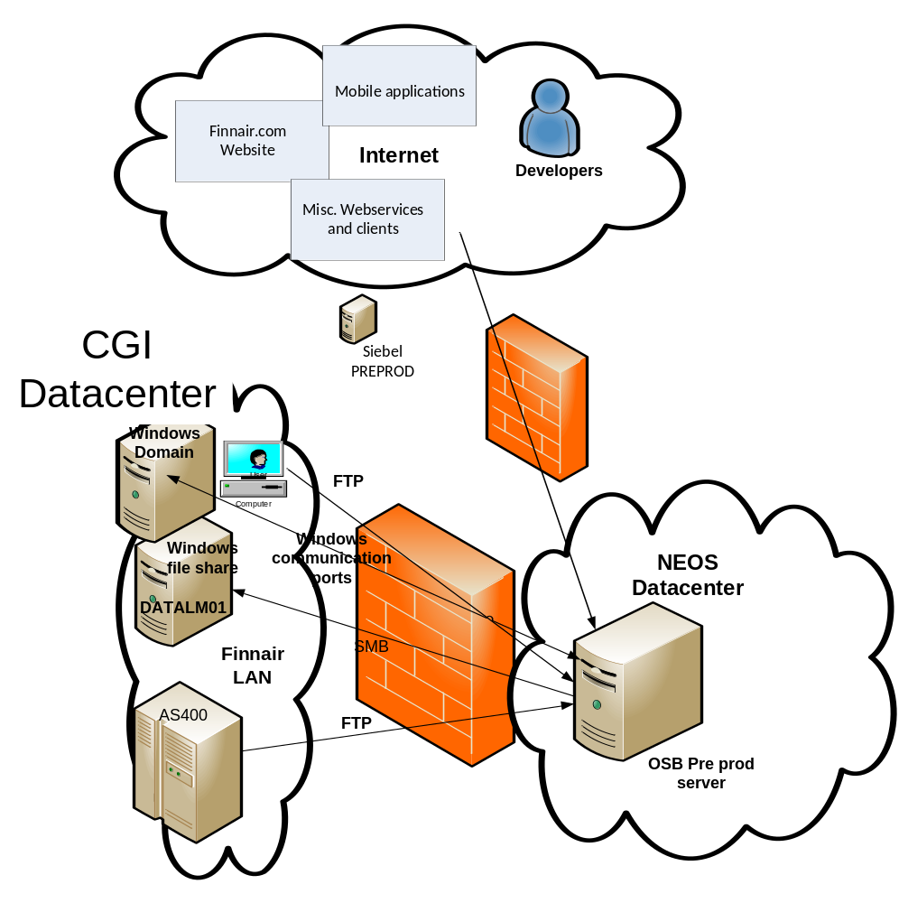

Figure 3-3 Current Operational Model
The above diagram shows the main platform nodes and their connections in the production environment. Actual server names and main application/purpose are placed on the diagram. The connections are at the specification level. The diagram does NOT SHOW ALL physical connections through hubs, wiring closets, and switches.
Component | Resides on | Notes
Developers | Internet | Connected by VPN
SMTP server | Finnair PROD LAN | For sending mails
Amadeus Weblogic | Finnair PROD LAN | Weblogic webservice
Siebel PREPROD | Finnair PROD LAN | Siebel webservice and database

Current Platform/Node Descriptions
Developer PC
Platform Node | Client PC
Description & Responsibility | Developer interface
Contents (Files & Databases) | N/A
Contents (System Components & Applications) | N/A
Products (Hardware, Operating Systems & Middleware) | Windows workstation  Admin console, telnet  There's an admin console accessed through a browser to access OSB configuration and an SSH connection to the server to manage more technical aspects of the OSB weblogic and OS in general.
Connectivity & Protocols | Outgoing connections: (from PC to OSB server)  - 22/TCP (Telnet)  - 443/TCP (HTTPS)

Admin PC
Platform Node | Client PC
Description & Responsibility | User interface
Contents (Files & Databases) | N/A
Contents (System Components & Applications) | Standard Finnair desktop / laptop
Products (Hardware, Operating Systems & Middleware) | Windows workstation  Admin console, telnet  There's an admin console accessed through a browser to access OSB configuration and an SSH connection to the server to manage more technical aspects of the OSB, weblogic and OS in general.
Connectivity & Protocols | Outgoing connections: (from PC to OSB server)  - 22/TCP (Telnet)  - 443/TCP (HTTPS)
Application server
Platform Node | dwhapa1
Description & Responsibility | Weblogic OSB server preprod
Contents (Files & Databases) | Weblogic OSB software
Contents (System Components & Applications) | WebLogic Server Version: 10.3.6.0,Oracle Service Bus Version: 11.1.1.7
Products (Hardware, Operating Systems & Middleware) | AIX 5.3 - 64 Bit  WebLogic Server Version: 10.3.6.0,  Oracle Service Bus Version: 11.1.1.7  Apache Tomcat 6.0.37
Connectivity & Protocols | Incomming connections  See Table 3-5 (3.2.2 Application Interfaces)  Outgoing connections  See Table 3-6 (3.2.2 Application Interfaces)

Current Server Details
Server function
Table 3-7 Server List (by Usage)
Server name | Node type | Env. | Primary Function | CPU  load | Main Application | Location
DWHAPA1 | Phys. | Dev | Weblogic OSB server | N/A | Oracle weblogic,  Oracle Service Bus (OSB) | NEOS DC

Server Specification
Table 3-8 Server List (by Specification)

Server name | Vendor Type/Model | Serial number | IP address | No. of CPUs | CPU Speed | Memory
DWHAPA1 | AIX 5.3 – 64 bit | N/A | 172.19.98.202 | 2 | 3000 Mhz | 16 GB

Current Storage and Database Information

Storage – SAN or local storage
Table 3-9 Current Storage Layout
Server Name | Server Function | Disk Type | No. of HBAs | Total
DWHAPA1 | Weblogic OSB server | Local attached HD | N/A | 120 GB

Current Network Model

Network Topology
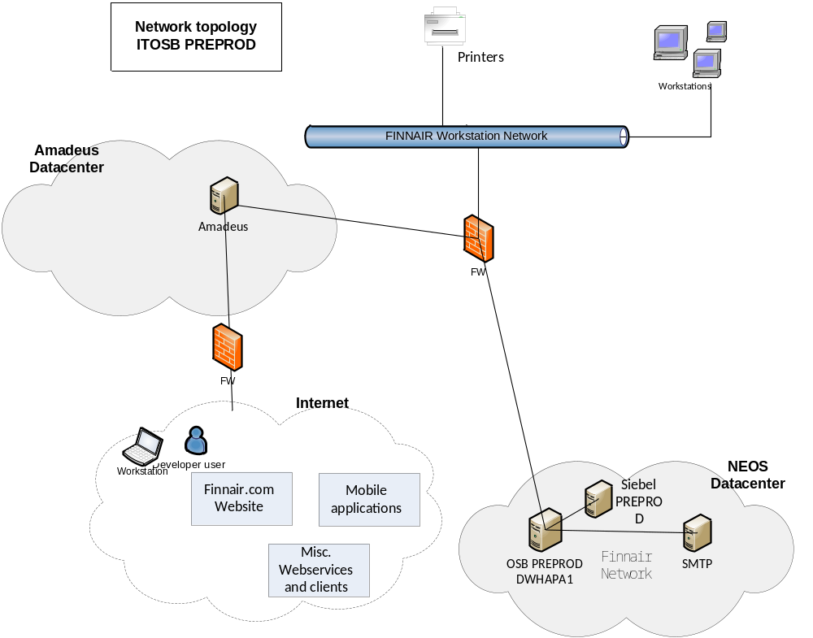

Current Network Connections
Table 3-10 Current Network Connections

Se Table 3-11 Application Interfaces

Current Environments Model
The numbers and platform types of servers supporting each environment are summarized in the following table:
Table 3-12 Current Environments

Environment /  Component | Pre Production | Copy | Prod | Total
DWHAPA1 | 1 | 0 | 0 | 1
Total | 1 | 0 | 0 | 1

Current Systems Management Model

Availability
The system is available for 24/7. No scheduled service windows.

Backup & Recovery Management
Table 3-13 TSM Backup List
Hostname | TSM Node Name | TSM Ver-sion | TSM Component Used (b-a, TDP for xxx) | GB Stored on TSM Server | Avg. GB of Daily Backup | TSM Schedules Used | TSM Client Option Set Used
DWHAPA1 | N/A | N/A | N/A | N/A | N/A | FULL weekly  Incremental daily | N/A

Operations Management
Standard server monitoring is used (Relic agent), on disk, CPU, memory, I/O etc.

Batch Management
Only local
Currently logs are shipped to an external log storage (Logstash).

Performance / Capacity Management
Currently no performance / capacity tool is used beside standard Windows server tools on ad-hoc basis.

Change Management
All changes to the environment beyond normal server maintenance activities are approved by the Service Manager.

Configuration / Inventory Management
N/A

Security Management
Standard Security Management process is used.

Disaster Recovery / Continuity Management
Restoring of servers and data are done by restoring from backups.

Problem Management
N/A

Data Management
N/A

Software Control & Distribution
Finnair is responsible for purchasing and managing all licenses and certificates.
Software is distributed / installed manually.

Service Level Management
N/A

Requirement Analysis
This section provides an analysis of the solution requirements. The key factors in the requirements are summarized and their implications are stated.
The requirements relative priority can be assigned using the MoSCoW rules of: Must Have = ‘M’, Should Have = ‘S’, Could Have = ‘C’ and Would Like To Have Later, But Will Not Include Now = ‘W’
In this document, the words and phrases that are used to define the significance of each particular requirement are capitalized. These words are:
Must Have This phrase, or the terms "REQUIRED" or "SHALL", mean that the definition is an absolute requirement of the specification.
Should Have While not critical to the success of the project delivery, "SHOULD" items are nearly as important and should be included if it is at all possible. "SHOULD" items are often as important as MUST items, however "SHOULD" items have workarounds allowing another way of satisfying the requirement.
Could Have "COULD" items are less critical and often seen as "nice to have". A few easily built Coulds in a delivery can increase customer satisfaction for little development cost.
Would Like To Have Later, But Will Not Include Now ("WON'T")
This phrase are either the least-critical or lowest-payback items. "WON'T" items are either dropped or reconsidered for reprioritization in later project increments. This, however doesn't make them any less important. Sometimes this is described simply as "Would like to have" in the future. This however leaves some ambiguity in the minds of the users as to its priority compared to the other marks.
Please use these terms consistently throughout the DID. Stick with MUST unless you have a very good reason to write SHALL, as “shall” has different meanings in English and American.

Applicable Documentation
All documentation MUST be written in English.

Acceptance
Technical IT tests (including Service Activation & Deactivation), application tests (Finnair defined) and user acceptance testing (Finnair defined) MUST be met.

Finnair Responsibilities
Finnair is responsible for:
- Installation instructions (should be provided by CGI).
- Creating and performing application tests.
- Creating and performing a user acceptance test.
- Decommissioning of old systems.
All instruction and documentation will be available in English

Change Cases
None.

Target Solution

Target Solution Overview
The new ITOSB PREPROD system will be built in the IBM dual site data centre Suvilahti and Munkkiniemi in Finland.
The system will be moved to a Virtual server by reinstalling OS and applications in IBM DC.

Target System Context

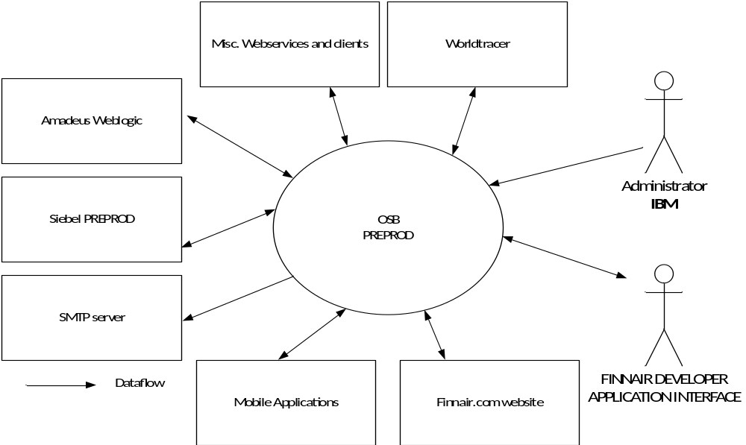
No changes compared to the system context diagram used in section 3.1, except Administrator connection will be IBM managed.

Target Operational Model

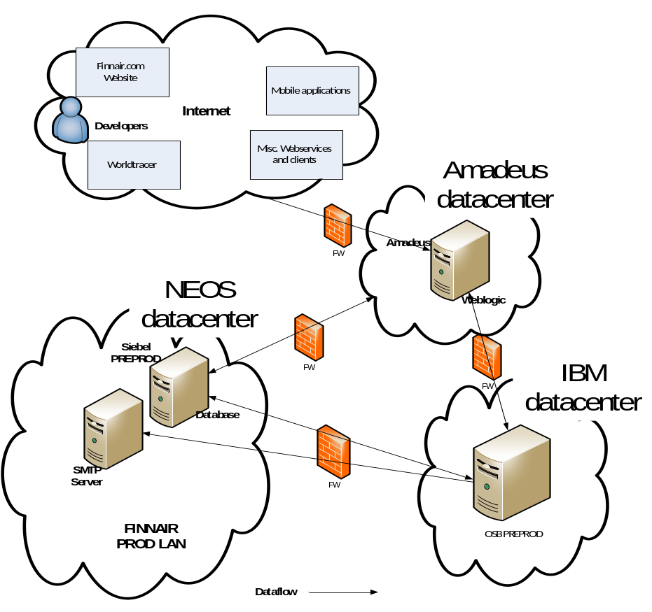

Figure 5-4 Target Operational Model

Architectural Decisions
It has been agreed with FINNAIR to reinstall servers with new version of OS.
Existing AIX 5.3 64 bit
Target AIX 7.1 64 bit
Since system will be relocated “AS-IS”, a risk letter must be created to handle Administrator access for Finnair Developers to server AYVATOSBAP01, when relocated to IBM.

Target Server details
Table 5-14 Target Server Details
New Server Name | Platform Type | Parent Platform | Environment | Network Zone | Location
AYVATOSBAP01 | Virtual | AIX 7.1 64 bit | Production | DMZ | IBM DC

Application server
Platform Node | AYVATOSBAP01
Description & Responsibility | Weblogic OSB server preprod
Contents (Files & Databases) | Weblogic OSB software
Contents (System Components & Applications) | WebLogic Server Version: 10.3.6.0,Oracle Service Bus Version: 11.1.1.7
Products (Hardware, Operating Systems & Middleware) | AIX 5.3 - 64 Bit  WebLogic Server Version: 10.3.6.0,  Oracle Service Bus Version: 11.1.1.7  Apache Tomcat 6.0.37
Connectivity & Protocols | Incoming connections  See Table 5-15 (Target Network Connections)  Outgoing connections  See Table 5-16 (Target Network Connections)

Server Summary
This reallocation is an AS-IS reallocation so the system context and the one function one server approach is not changed from the current system context.
Server Function
Table 5-17 Target Server Function
Server Name | Server Function | Env. | OS | Location
AYVATOSBAP01 | OSB PREPROD | Production | AIX 7.1 64 bit | IBM DC
Server Specification
Table 5-18 Target Server Specifications
Server Name | Type/Model | Serial Number | No. of CPUs | CPU Speed | Memory | IP Address  Host Name
AYVATOSBAP01 | Virtual | N/A | 2 | 3000 Mhz | 16 GB | 157.200.5.29
The Time Zone of the server is set to Eastern Europe Time (Central European Time + 1 hour).
Regional Settings: English
(except for "Language for non-Unicode programs" which is set to English)
Software Components
Table 5-19 Target Application/Software List
Nr. | Server Name | Software Component | Version | Vendor | Method | Comment
1 | AYVATOSBAP01 | Weblogic | 10.3.0.6 | Oracle | Re-installation | IBM will install
2 | AYVATOSBAP01 | Oracle Service Bus (OSB) | 11.1.1.7 | Oracle | Re-installation | IBM will install

Target Storage & Database Information
Storage
Table 5-20 Target Storage Layout
Server Name | Server Function | Disk Type | PPRC | Flash Copy | No. of HBAs | Layout
AYVATOSBAP01 | OSB PREPROD | Local Disk | N/A | N/A | N/A | 120 GB  Shared in 10 volumes  /weblogic largest volume, occupying 80%  Disk layout:  /dev/hd4 /  /dev/hd2 /usr  /dev/hd9var /var  /dev/hd3 /tmp  /dev/hd1 /home  /proc /proc  /dev/weblogic /weblogic  /dev/optnew /opt

Target Network Model

Target Network Topology
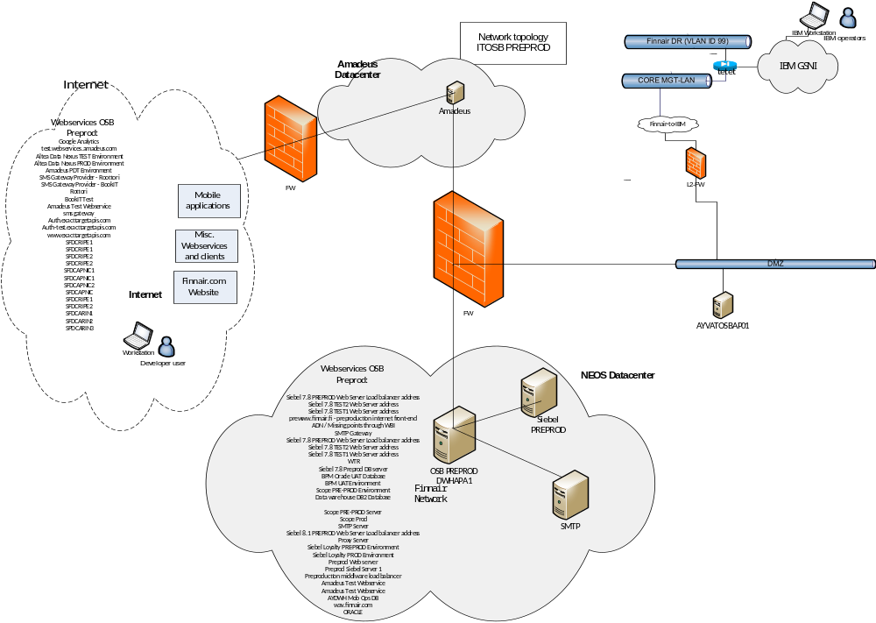

Target Network Connections
Table 5-21 Target Server IP addresses
Server Name | Platform Type | Env | Network Zone | Location | In IP | Out IP | Mgmt IP | RSA IP
AYVATOSBAP01 | Virtual | Prod | DMZ | IBM DC | 157.200.5.29 | 157.200.5.29 | N/A | N/A

Table 5-22 Target Network Connections
From | Network Zone | Out IP | To | Network Zone | In IP | Destination Port/App/Protocol
Developer PC | Internet | Dynamic | AYVATOSBAP01 | DMZ | 157.200.5.29 | 22 – SSH, 443 - HTTPS  7005, 7070, 7080 – HTTP  7043, 7053, - HTTPS  8005, 8070, 8080 - HTTP  8043, 8053- HTTPS
Admin PC | IBM GSNI | Dynamic | AYVATOSBAP01 | DMZ | 157.200.5.29 | 22 – SSH, 443 - HTTPS  7005, 7070, 7080 - HTTP  7043, 7053, - HTTPS  8005, 8070, 8080 - HTTP  8043, 8053- HTTPS
Finnair Network | FINNAIR | 157.200.12.200, 157.200.12.201, 157.200.121.75  157.200.120.0/22 Fin1x  157.200.86.0/23 Full AY VPN  ( To be verified by Amadeus) | OSB Application server | DMZ | 157.200.5.29 | 22 - SSH  7005, 7070, 7080 - HTTP  7043, 7053, - HTTPS  8005, 8070, 8080 - HTTP  8043, 8053- HTTPS
Logica Access | Internet | Logica VPN (source IP to be verified) | OSB Application server | DMZ | 157.200.5.29 | 22 - SSH  7005, 7070, 7080 - HTTP  7043, 7053, - HTTPS  8005, 8070, 8080 - HTTP  8043, 8053- HTTPS
ITC Infotech Network / VPN | N/A | 192.168.96.0/24 | OSB Application server | DMZ | 157.200.5.29 | 22 - SSH  7005, 7070, 7080 - HTTP  7043, 7053, - HTTPS  8005, 8070, 8080 - HTTP  8043, 8053- HTTPS
bSiebel App 1 | FINNAIR | 172.19.98.74 | OSB Application server | DMZ | 157.200.5.29 | 7070
Siebel 8.1 PROD App Server | FINNAIR | 172.19.98.82 | OSB Application server | DMZ | 157.200.5.29 | 80
Pre-prod application servers | FINNAIR | 172.19.98.236 | OSB Application server | DMZ | 157.200.5.29 | 5080, 6080
PRE-PROD INFORMATICA SERVER | N/A | 10.100.133.130 | OSB Application server | DMZ | 157.200.5.29 | 7005
OSB Application server | DMZ | 157.200.5.29 | Siebel 7.8 PREPROD Web Server Load balancer address | N/A | 157.200.88.165 | 80, 443
OSB Application server | DMZ | 157.200.5.29 | Siebel 7.8 TEST2 Web Server address | N/A | 157.200.88.176 | 80
OSB Application server | DMZ | 157.200.5.29 | Siebel 7.8 TEST1 Web Server address | N/A | 157.200.88.170 | 80
OSB Application server | DMZ | 157.200.5.29 | prewww.finnair.fi - preproduction internet front-end | N/A | 157.200.15.211 | 80, 443
OSB Application server | DMZ | 157.200.5.29 | ADN / Missing points through WBI | N/A | 157.200.18.62 | 7080
OSB Application server | DMZ | 157.200.5.29 | SMTP Gateway | N/A | 157.200.13.44 | 25
OSB Application server | DMZ | 157.200.5.29 | Siebel 7.8 PREPROD Web Server Load balancer address | N/A | 157.200.88.165 | 80, 443
OSB Application server | DMZ | 157.200.5.29 | Siebel 7.8 TEST2 Web Server address | N/A | 157.200.88.176 | 80
OSB Application server | DMZ | 157.200.5.29 | Siebel 7.8 TEST1 Web Server address | N/A | 157.200.88.170 | 80
OSB Application server | DMZ | 157.200.5.29 | WTR | N/A | 57.250.224.196 | 443
OSB Application server | DMZ | 157.200.5.29 | Siebel 8.1 PREPROD Web Server Load balancer address | FINNAIR | 172.19.98.10 | 80, 443
OSB Application server | DMZ | 157.200.5.29 | Siebel 7.8 Preprod DB server | N/A | 157.200.88.180 | 50000
OSB Application server | DMZ | 157.200.5.29 | Google Analytics | Internet | 74.125.39.101, 74.125.39.102, 74.125.39.113, 74.125.39.138, 74.125.39.139, 74.125.39.100 | 80
OSB Application server | DMZ | 157.200.5.29 | test.webservices.amadeus.com | Internet | 82.150.226.67 | 443
OSB Application server | DMZ | 157.200.5.29 | www.google-analytics.com | Internet | 209.85.146.100, 209.85.146.101, 209.85.146.102, 209.85.146.113, 209.85.146.138, 209.85.146.139 | 80
OSB Application server | DMZ | 157.200.5.29 | Proxy Server | FINNAIR | 172.19.100.164 | 3128
OSB Application server | DMZ | 157.200.5.29 | BPM Oracle UAT Database | N/A | 157.200.19.252 | 1525
OSB Application server | DMZ | 157.200.5.29 | Altea Data Nexus TEST Environment | Internet | test-ads.webservices.ay.amadeus.net:22006  193.23.185.93:22006 | 22006,80
OSB Application server | DMZ | 157.200.5.29 | Altea Data Nexus PROD Environment | Internet | prod-ads.webservices.ay.amadeus.net:22006  194.76.166.93 | 22006,80
OSB Application server | DMZ | 157.200.5.29 | Amadeus PDT Environment | Internet | test.webservices.1a.amadeus.net  193.23.185.67 | 22006, 80
OSB Application server | DMZ | 157.200.5.29 | SMS Gateway Provider - Roottori | Internet | gw1.roottori.fi  87.108.54.100 | 80, 443
OSB Application server | DMZ | 157.200.5.29 | SMS Gateway Provider - BookIT | Internet | es30.bookit.net  193.185.151.60 | 8080, 443
OSB Application server | DMZ | 157.200.5.29 | Siebel Loyalty PRE-PROD Environment | FINNAIR | 172.19.98.10 | 80
OSB Application server | DMZ | 157.200.5.29 | Siebel Loyalty PROD Environment | FINNAIR | 172.19.96.234 | 80
OSB Application server | DMZ | 157.200.5.29 | BPM UAT Environment | N/A | 157.200.18.17 | 8080, 8070,  9090, 9080
OSB Application server | DMZ | 157.200.5.29 | Scope PRE-PROD Environment | N/A | preprod.finnair.fi  157.200.18.11 | 80
OSB Application server | DMZ | 157.200.5.29 | Data warehouse DB2 Database | N/A | 157.200.16.188 | 50000
OSB Application server | DMZ | 157.200.5.29 |  | N/A | 157.200.88.185 | 80, 443
OSB Application server | DMZ | 157.200.5.29 | Scope PRE-PROD Server | N/A | 157.200.74.164 | 80
OSB Application server | DMZ | 157.200.5.29 | Scope Prod | N/A | 157.200.75.35 | 80, 443
OSB Application server | DMZ | 157.200.5.29 | Rottori | Internet | 62.61.85.34 | 80, 443
OSB Application server | DMZ | 157.200.5.29 | Preprod Web server | FINNAIR | 172.19.98.10 | 9704
OSB Application server | DMZ | 157.200.5.29 | Preprod Siebel Server 1 | FINNAIR | 172.19.98.74 | 1414
OSB Application server | DMZ | 157.200.5.29 | Preproduction middlware load balancer | FINNAIR | 172.19.98.236 | 80 ,443
OSB Application server | DMZ | 157.200.5.29 | Amadeus Test Webservice | FINNAIR | nodeA1.test.webservices.1a.amadeus.com/ 171.17.15.33 | 80/443
OSB Application server | DMZ | 157.200.5.29 | BookIT Test | Internet | es30.bookit.net/193.185.151.60 | 8080/443
OSB Application server | DMZ | 157.200.5.29 | SMTP Server | N/A | 157.200.93.25 | 25
OSB Application server | DMZ | 157.200.5.29 | Amadeus Test Webservice | Internet | www.oneworld.com (66.96.130.69) | 80/443
OSB Application server | DMZ | 157.200.5.29 | Amadeus Test Webservice | Internet | www.web-mn.com (23.23.175.3, 107.20.199.207) | 80/443
OSB Application server | DMZ | 157.200.5.29 | Amadeus Test Webservice | Internet | go.urbanairship.com (184.31.89.14) | 80/443
OSB Application server | DMZ | 157.200.5.29 | sms gateway | Internet | 217.140.134.8 | 80
OSB Application server | DMZ | 157.200.5.29 | Amadeus Test Webservice | FINNAIR | sns.eu-west-1.amazonaws.com (176.32.110.38 )dynamic ip address | 443
OSB Application server | DMZ | 157.200.5.29 | AYDWH Mob Ops DB | FINNAIR | 10.100.160.90, 10.100.160.91, 10.100.160.100, 10.100.160.101, 10.100.160.102 | 1521
OSB Application server | DMZ | 157.200.5.29 | Amadeus Test Webservice | Internet | webservice-qa.worldtracer.aero: (57.250.200.177) | 443
OSB Application server | DMZ | 157.200.5.29 |  | N/A | 157.200.32.40 | 7300
OSB Application server | DMZ | 157.200.5.29 |  | N/A | 157.200.32.40 | 7301
OSB Application server | DMZ | 157.200.5.29 | wav.finnair.com | FINNAIR | 171.17.128.42 | 80/443
OSB Application server | DMZ | 157.200.5.29 |  | FINNAIR | 171.17.128.123 | 80/443
OSB Application server | DMZ | 157.200.5.29 |  | N/A | 157.200.40.0/22 | 80/443
OSB Application server | DMZ | 157.200.5.29 |  | N/A | 157.200.40.0/22 | 6379
OSB Application server | DMZ | 157.200.5.29 |  | N/A | 157.200.74.158 | 389
OSB Application server | DMZ | 157.200.5.29 |  | Internet | Auth.exacttargetapis.com | 80,443
OSB Application server | DMZ | 157.200.5.29 |  | Internet | Auth-test.exacttargetapis.com | 80,443
OSB Application server | DMZ | 157.200.5.29 |  | Internet | www.exacttargetapis.com | 80,443
OSB Application server | DMZ | 157.200.5.29 | SFDCRIPE1 | Unknown | 85.222.128.0/19 | 80/443
OSB Application server | DMZ | 157.200.5.29 | SFDCRIPE1 | Unknown | 85.222.128.0/19 | 1024–66535
OSB Application server | DMZ | 157.200.5.29 | SFDCRIPE2 | Unknown | 185.79.140.0/22 | 80/443
OSB Application server | DMZ | 157.200.5.29 | SFDCRIPE2 | Unknown | 185.79.140.0/22 | 1024–66535
OSB Application server | DMZ | 157.200.5.29 | SFDCAPNIC1 | Unknown | 202.129.242.0/23 | 80/443
OSB Application server | DMZ | 157.200.5.29 | SFDCAPNIC1 | Unknown | 202.129.242.0/23 | 1024–66535
OSB Application server | DMZ | 157.200.5.29 | SFDCAPNIC2 | Unknown | 182.50.76.0/22 | 80/443
OSB Application server | DMZ | 157.200.5.29 | SFDCAPNIC | Unknown | 182.50.76.0/2 | 1024–66535
OSB Application server | DMZ | 157.200.5.29 | SFDCRIPE1 | Unknown | 85.222.128.0/19 | 80/443
OSB Application server | DMZ | 157.200.5.29 | SFDCRIPE2 | Unknown | 185.79.140.0/22 | 80/443
OSB Application server | DMZ | 157.200.5.29 | SFDCARIN1 | Unknown | 96.43.144.0/20 | 80/443
OSB Application server | DMZ | 157.200.5.29 | SFDCARIN2 | Unknown | 136.146.0.0/15 | 80/443
OSB Application server | DMZ | 157.200.5.29 | SPDCARIN3 | Unknown | 204.14.232.0/21 | 80/443
OSB Application server | DMZ | 157.200.5.29 | ORACLE | FINNAIR | 10.100.132.198 | 1521
OSB Application server | DMZ | 157.200.5.29 | ORACLE | FINNAIR | 10.100.132.197 | 1521
OSB Application server | DMZ | 157.200.5.29 | ORACLE | FINNAIR | 1.010.016.042 | 1521
OSB Application server | DMZ | 157.200.5.29 | SMTP | FINNAIR | 172.19.100.171 | 25
OSB Application server | DMZ | 157.200.5.29 | Oracle | NEOS | SCAN-DWPRAC.finnair.fi  10.100.132.200  10.100.132.198  scan-mdtrac.finnair.fi  munaydwhtdbr05.finnair.fi | 1521

Target Systems Management Model
Target system will be placed in the standard Finnair network in the DC.

Availability
The system is available for 24/7. No scheduled service windows.

Backup & Recovery Management
If IBM DC: The TSM tool will be used for backup and recovery.

Table 5-23 TSM Backup List
Hostname | TSM Node Name | TSM Ver-sion | TSM Component Used (b-a, TDP for xxx) | TSM Schedules Used | TSM Client Option Set Used
AYVATOSBAP01 | AYVATOSBAP01 | N/A | n/a | DAYLY_INCR  at 21:00 | Standard
Backup schedules; Daily Incremental; Weekly Full
Retention time: The weekly full backup must be stored for 3 years.

Operations Management
The Tivoli tool will be used for Monitoring.
Standard server monitoring is used, on disk, CPU, memory, i/o etc.
No special operational management on the application level

Batch Management
N/A

Performance / Capacity Management
Currently no performance / capacity tool is used beside standard Windows server tools on ad-hoc basis.

Change Management
The ISM Maximo tool will be used for change management.

Configuration / Inventory Management
The standard approach agreed at the contract level will be followed.

Security Management
The standard approach agreed at the contract level will be followed.

Disaster Recovery / Continuity Management
There is no specific disaster recovery plan for this application.

Problem Management
The standard approach agreed at the contract level will be followed.

Data Management
No change in data management.

Software Control & Distribution
Finnair is responsible for purchasing and managing all licenses.
Software is distributed / installed manually.

Service Level Management
Service Hours and availability per Service Class
Enterprise Platform Availability | Expected Service Level | Minimum Service Level | Service Hours
Gold | 99.90% | 99.50% | 24/7
Silver | 99.50% | 99.00% | 24/7
Bronze | 98.00% | 95.00% | 08:00 – 17:00

Service Classes Definitions for Data Centre Servers.
Service Class | Description
Gold | High availability configuration, with built in redundancy for disks, network adapters, standby processor, available to take workload and highly available software such as Microsoft Cluster Services or HACMP or clustering provided by platform (e.g. VMware vMotion) to automatically control fail over to standby. Data is replicated between data centres. Applications running on “Gold” service levels must be able to support high-availability fail-over operations.
Silver | Standard in-built server hardware redundancy is required (e.g. PSUs, SAN/LAN adapters, RAID/Mirror/Redundancy for disk environment). However, hot, warm or cold fail-over is not included.
Bronze | Standard server with single system, mirrored system disk or RAID.

SoftLayer System Configurations and Service Classes.
Service Class | System Configuration
Gold | High availability configuration, built in redundancy for disks, network adapters, active or standby processor available to take workload and highly available software such as Microsoft Cluster Services or clustering provided by virtualization platform (e.g. VMware vMotion) to automatically control fail over to standby. In the event of a failure of the primary SoftLayer point of delivery the services will be automatically transferred to an alternative SoftLayer point of delivery. Workloads placed on Gold level must be able to support high-availability functionality (load balancing, active-active cluster or active-passive fail-over operations).
Silver | Standard virtual server with standard system redundancy.
Bronze | Standard virtual server with standard system redundancy.

The target application will be placed in service class: Gold

Testing and Validation
IBM will perform systems test, i.e. verifying that application ready server(s) has been installed with the requested OS and storage, standard middleware (monitoring, backup, etc.), and firewalls has been opened.
Finnair will perform technical tests and user application tests.

System Acceptance
Reference to section 4.2.

Deployment
Deployment and go-live according to Cutover plan, see section 6.1.

Documentation
Documentation per application for the below tasks is stored in the Finnair Europe Team room
# | Task
1 | Choose Servers for Server Migration – the Wave
2 | Checkpoint: Staff for Wave and access rights in place incl. 3rd party
3 | Establish information about Server AS IS environment incl. Applications and interfaces
4 | Customer sign off concerning Server SLA level, physical / virtual server(s) in target
5 | Check Readiness of Target environment for XXX of Servers (VMware, SAN, NW, Licenses)
6 | Check availability of physical Servers in target as needed and agreed
7 | Fill in Order Form for Server Factory to build Application Ready Servers in Target
8 | Install DB / MW on target servers as needed
9 | Install Applications on new servers in Target environment
10 | Agree on method of Data Migration and initiate the process
11 | Perform an initial full backup of Finnair files per Server Image
12 | Perform a restore test of files initially backed up per Server Image.
13 | Provide Test Cases and Test Plan
14 | Provide DID (Detailed Implementation Document) for transformation of Servers
15 | Provide Cutover Plan
16 | Provide Change Request and agree (Finnair / IBM) on date / time for transformation
17 | Provide Operator Instructions for Servers in target environment.
18 | Perform Kick Off meeting with participants in Cutover Change
19 | Perform initial User Acceptance Test
20 | Complete delta Data Migration
21 | Perform Cutover during Change Window / Change DNS / Management of interfaces
22 | Perform final User Acceptance Test
23 | GO LIVE / NO GO Decision
24 | Inform Helpdesk that servers are in production in Target
25 | Perform Handover Process to BAU Steady State Incl. Activation of Monitoring
26 | Check Compliance Status
27 | Check that Service Management disciplines are implemented according to Schedule 8
28 | Agree on Decommission of Source Servers
29 | Checkpoint: Wave Documentation in place

Transformation guidelines
Rules for relocating applications to SL DC and IBM DC
- All applicable servers must be moved to SL DC
- All applicable physical servers must be virtualized
- One to one cloning is preferred relocation method
- If server can’t be cloned it will be re-installed on IBM side.
- Relocating to IBM DC needs documented justification

Service Move
The primary communication deliverable is the Cutover Plan.

Cutover Plan
The Cutover Plan is a plan that details exactly what tasks must be done in the various functional areas of an IT organization to provide for a successful relocation of one or more components of the IT infrastructure. The plan is a living document that is updated and carried out throughout the life of the project. The Cutover Plan is owned by the PM and will be finalized after this DID is approved. It can be requested from the Project Manager.

Move Day Timeline
The Complex Relocation Move Day Timeline is a task-by-task description of how a specific move (server, mainframe storage, etc.) should occur under ideal conditions. The timeline is limited to the actual move day(s) and takes into account the necessary move strategy for the particular function; it incorporates times, roles, and dependencies for the actual move day. Contained within this plan are a series of decision points that determine if it is safe to continue with the move or if the environment should be restored to its original condition.
The detailed timeline is part of the Cutover Plan.

Communication plan
The communication plan is part of the cutover plan.

Rollback plan
The Rollback plan is part of the cutover plan.

Risk Assessment
The following risks have been identified.
# | Risk | Risk Description | Prob. | Impact on |  |  | Strategy
 |  |  |  | Cost | Sched. | Quality | Strategy
1 | Relocation fails | Relocation fails and cause cannot be determined within a reasonable time | LOW | LOW | MED | LOW | Roll back. A thorough function test mitigates this risk
2 | Errors caused by the migration from AIX 5.3 to AIX 7.1 will not be identified before the relocation |  | LOW | LOW | MED | MED | Troubleshoot and correct any issues.
3 | One or more of the connections will fail during the relocation | Many port openings to and from OSB server has been done, some could be failing after setup of new server | LOW | LOW | MED | HIGH | Troubleshoot and correct any issues.
End of Document

